Name: C.manojkumar

Roll N0:727721eucb031

Data Using Structure :

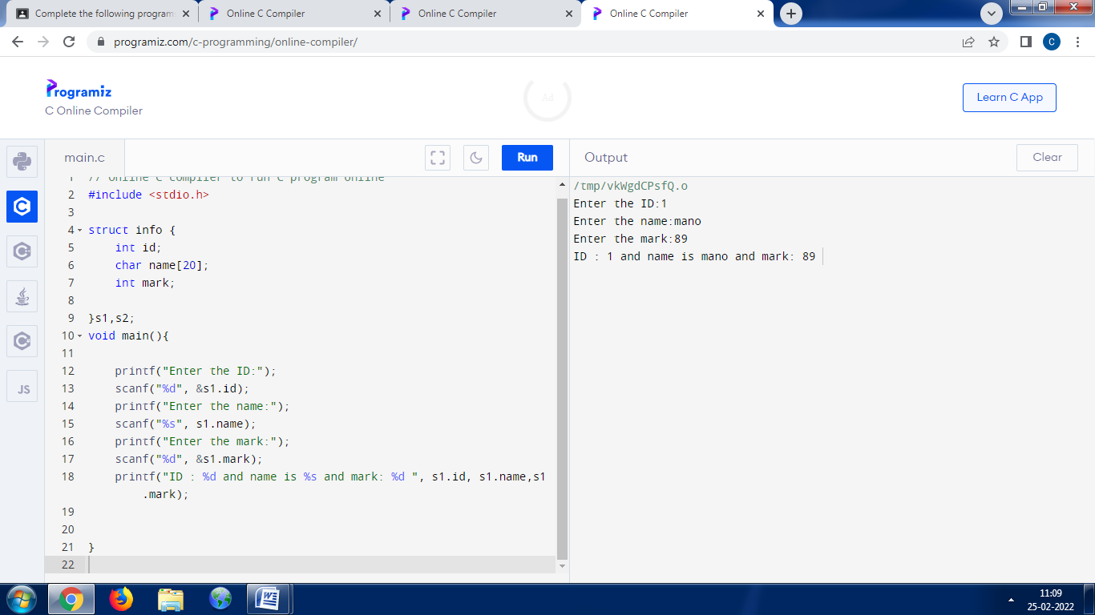

Adding of two distance:

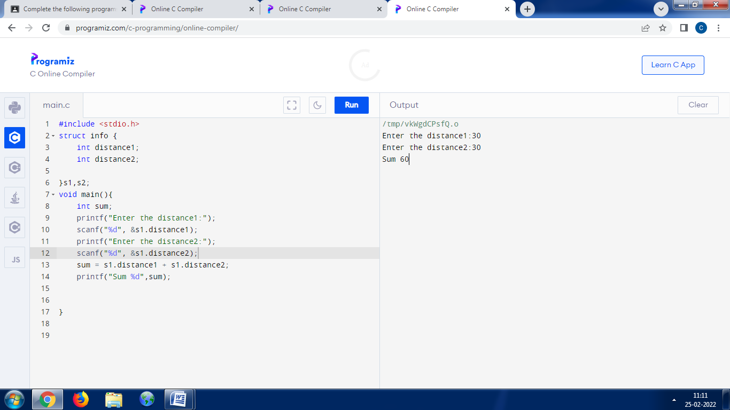

Sorting using Structure

